# Topic: Text Mining (NLP)

**Instructions:**

Please share your answers filled in-line in the word document. Submit code separately wherever applicable.

Please ensure you update all the details:

**Name: DHEERAJ MISHRA Batch ID: DS_ 01072021**

**Topic: Text Mining and NLP**

**Grading Guidelines:**

**1. An assignment submission is considered complete only when correct and executable code(s) are submitted along with the documentation explaining the method and results. Failing to submit either of those will be considered an invalid submission and will not be considered for evaluation.**

**2. Assignments submitted after the deadline will affect your grades.**

**Grading Criteria:**

|  |  |  |  |  |  |
| --- | --- | --- | --- | --- | --- |
| **Submission** | **Date** |  |  | **Submission** | **Date** |
| Correct | On time | A | 100 |  |  |
| 80% & above | On time | B | 85 | Correct | Late |
| 50% & above | On time | C | 75 | 80% & above | Late |
| 50% & below | On time | D | 65 | 50% & above | Late |
|  |  | E | 55 | 50% & below |  |
| Copied/No Submission |  | F | 45 |  |  |

* **Grade A: (>= 90):** When all assignments are submitted on or before the given deadline.
* **Grade B: (>= 80 and < 90):** 
  + When assignments are submitted on time but less than 80% of problems are completed.

(OR)

* + All assignments are submitted after the deadline.
* **Grade C: (>= 70 and < 80):** 
  + When assignments are submitted on time but less than 50% of the problems are completed.

(OR)

* + Less than 80% of problems in the assignments are submitted after the deadline.
* **Grade D: (>= 60 and < 70):**
  + Assignments submitted after the deadline and with 50% or less problems.
* **Grade E: (>= 50 and < 60):** 
  + Less than 30% of problems in the assignments are submitted after the deadline.

(OR)

* + Less than 30% of problems in the assignments are submitted before the deadline.
* **Grade F: (< 50):** No submission (or) malpractice.

**Hints:**

1. **Business Problem**
   1. **What is the business objective?**
   2. **Are there any constraints?**
2. **Work on each feature of the dataset to create a data dictionary as displayed in the below image:**

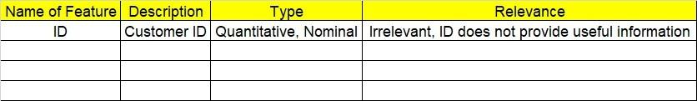

**2.1 Make a table as shown above and provide information about the features such as its data type and its relevance to the model building. And if not relevant, provide reasons and a description of the feature.**

1. **Data Pre-processing**

**3.1 Data Cleaning, Feature Engineering, etc.**

**3.2 Outlier Treatment**

1. **Exploratory Data Analysis (EDA):**
   1. **Summary**
   2. **Univariate analysis**
   3. **Bivariate analysis**
2. **Model Building**
   1. **Extract text data from websites such as Amazon, Snapdeal, IMDB, Twitter, etc.**
   2. **Clean the data and build a word cloud for both positive and negative words. Perform Sentiment Analysis as well.**
   3. **Briefly explain the model output in the documentation.**
3. **Write about the benefits/impact of the solution - in what way does the business (client) benefit from the solution provided?**

**Problem Statement: -**

In the era of widespread internet use, it is necessary for businesses to understand what the consumers think of their products. If they can understand what the consumers like or dislike about their products, they can improve them and thereby increase their profits by keeping their customers happy. For this reason, they analyze the reviews of their products on websites such as Amazon or Snapdeal by using text mining and sentiment analysis techniques.

Task 1:

1. Extract reviews of any product from e-commerce website Amazon.
2. Perform sentiment analysis on this extracted data and build a unigram and bigram word cloud.
3. Business analysis:-

Maximize Sentiment analysis on reviews

1. Data understanding :-
2. Data collected from amazon
3. From amazon through web scrapping MI NOTE10 reviews obtained
4. Data is in form of reviews that is text
5. Data type is strings or char
6. Data cleansing:-
7. Converting string to lower case
8. Special characters are removed through regular expression
9. Tokenization is done to obtain single words
10. Stop words are removed
11. For unigram TFIDF is applied to get weightage of words
12. Lemmetizer is used for base words
13. Empty spaces are removed
14. Count vectorizer used for frequency count of bigrams
15. EDA :-

1. Frequency count for each words

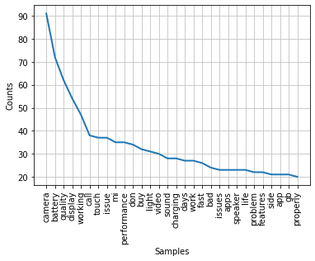

1. MODEL BUILDING :-

FOR UNIGRAM:-

1. Word cloud for unigram

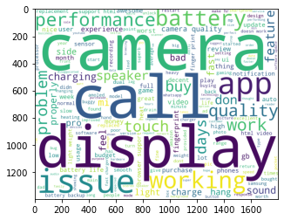

1. Positive word cloud for unigram

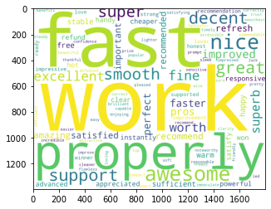

1. Negative word cloud for unigram

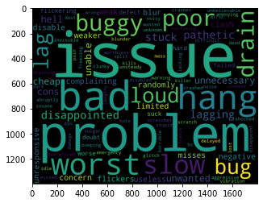

1. Sentiment analysis for unigram

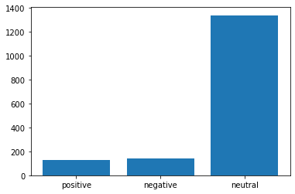

1. From Sentiment analysis for unigram it is clear that neutral reviews are more.

FOR BIGRAM:-

1. Word cloud for bigram

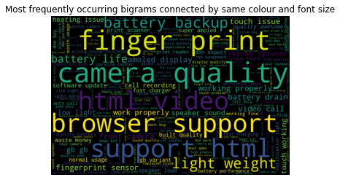

1. Histogram for polarity

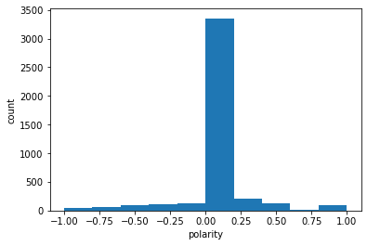

1. From Histogram for polarity it is clear that more neutral reviews are there
2. Benefit :-

From above information about unigram and bigram it is clear that more reviews are neutral . So some modification require in the MI NOTE10 product.

Task 2:

1. Extract reviews for any movie from IMDB and perform sentiment analysis.
2. Business analysis:-

Maximize Sentiment analysis on reviews

1. Data understanding :-
2. Data collected from IMdb
3. From IMdb through web scrapping FAMILY MAN reviews obtained
4. Data is in form of reviews that is text
5. Data type is strings or char
6. Data cleansing:-
7. Converting string to lower case
8. Special characters are removed through regular expression
9. Tokenization is done to obtain single words
10. Stop words are removed
11. For unigram TFIDF is applied to get weightage of words
12. Lemmetizer is used for base words
13. Empty spaces are removed
14. Count vectorizer used for frequency count of bigrams
15. EDA :-

1. Frequency count for each words

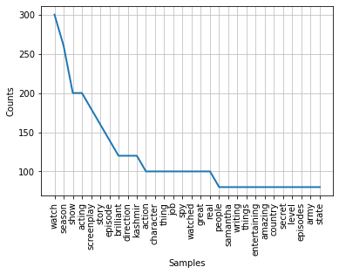

1. MODEL BUILDING :-

FOR UNIGRAM:-

1. Word cloud for unigram

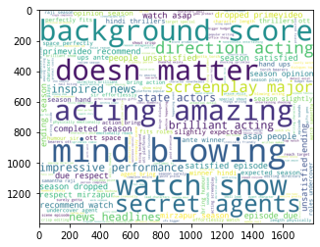

1. Positive word cloud for unigram

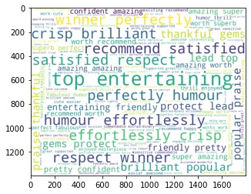

1. Negative word cloud for unigram

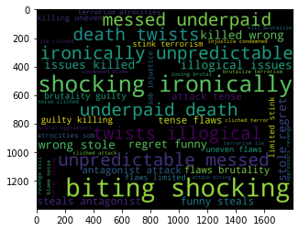

1. Sentiment analysis for unigram

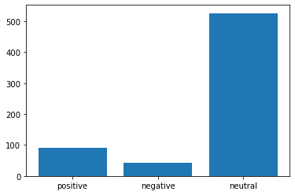

1. From Sentiment analysis for unigram it is clear that neutral reviews are more.

FOR BIGRAM:-

1. Word cloud for bigram

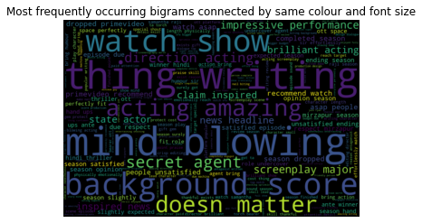

1. Histogram for polarity

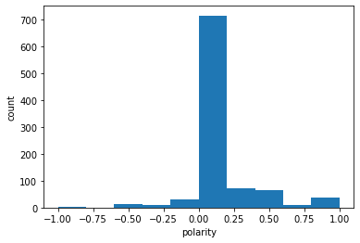

1. From Histogram for polarity it is clear that more neutral reviews are there
2. Benefit :-

From above information about unigram and bigram it is clear that more reviews are neutral but less negative response. So next season can be made.

Task 3:

1. Choose any other website on the internet and do some research on how to extract text and perform sentiment analysis
2. Business analysis:-

Maximize Sentiment analysis on reviews

1. Data understanding :-
2. Data collected from flipkart
3. From flipkart through web scrapping MITV 43” reviews obtained
4. Data is in form of reviews that is text
5. Data type is strings or char
6. Data cleansing:-
7. Converting string to lower case
8. Special characters are removed through regular expression
9. Tokenization is done to obtain single words
10. Stop words are removed
11. For unigram TFIDF is applied to get weightage of words
12. Lemmetizer is used for base words
13. Empty spaces are removed
14. Count vectorizer used for frequency count of bigrams
15. EDA :-

1. Frequency count for each words

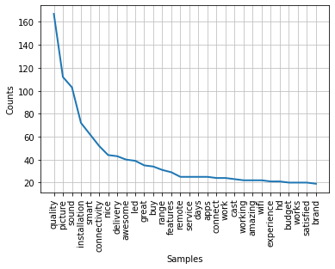

1. MODEL BUILDING :-

FOR UNIGRAM:-

1. Word cloud for unigram

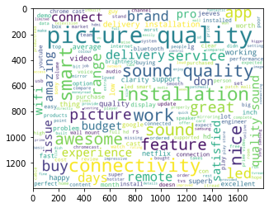

1. Positive word cloud for unigram

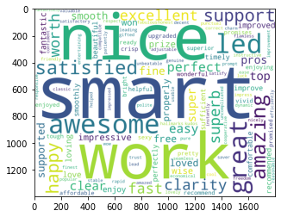

1. Negative word cloud for unigram

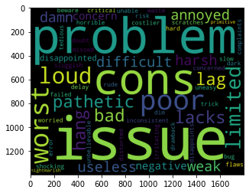

1. Sentiment analysis for unigram

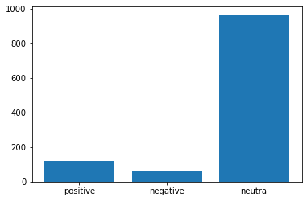

1. From Sentiment analysis for unigram it is clear that neutral reviews are more.

FOR BIGRAM:-

1. Word cloud for bigram

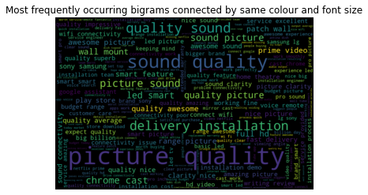

1. Histogram for polarity

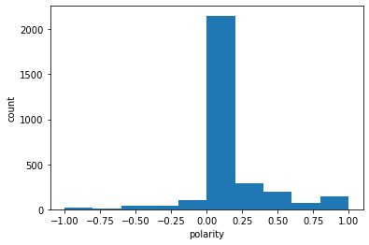

1. From Histogram for polarity it is clear that more neutral reviews are there
2. Benefit :-

From above information about unigram and bigram it is clear that more reviews are neutral . So some modification require in the MI TV 43” product.